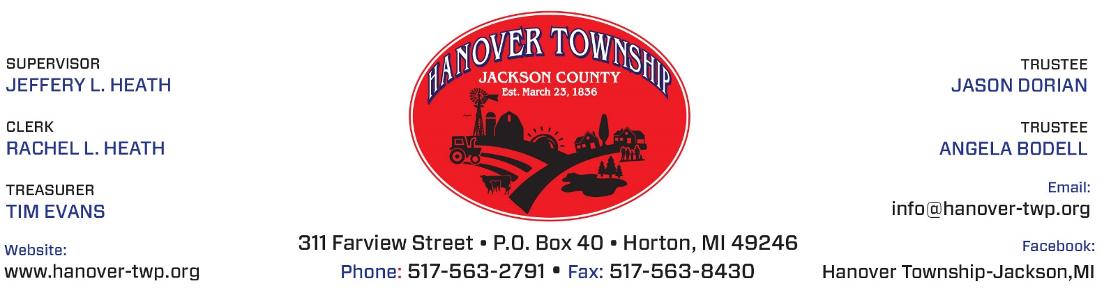
Hanover Township Office will be CLOSED on the following dates in observance of the holiday:

WEDNESDAY & THURSDAY
November 27 & 28, 2019

Rachel Heath, Clerk

