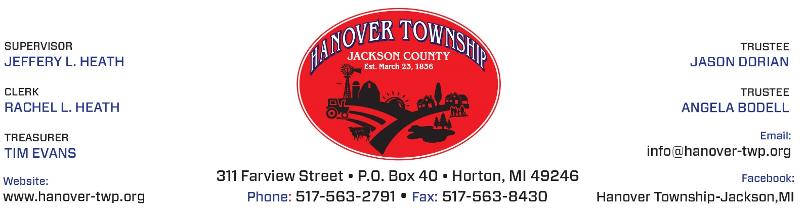

In observation of
Veterans Day,
Hanover Township Office will be
Closed Monday, November 11, 2019.

Rachel Heath, Clerk

