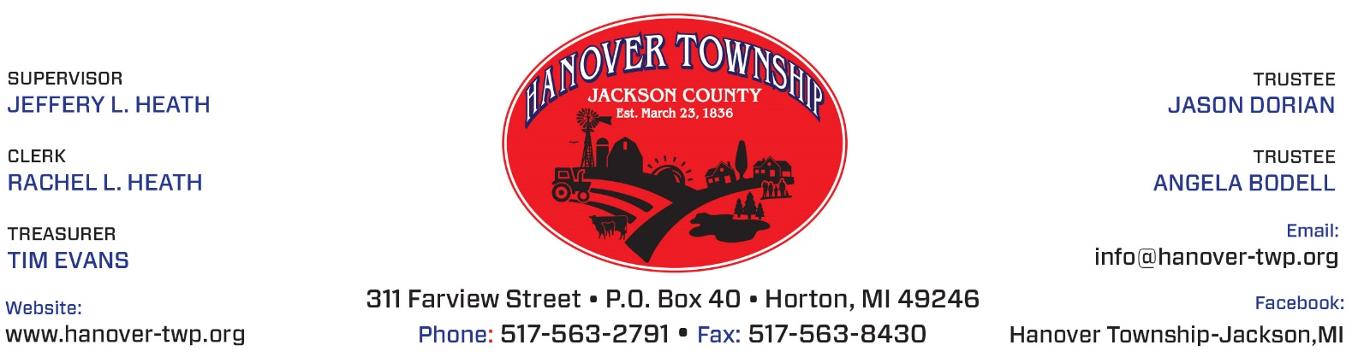

In observation of
The holidays,
Hanover Township Office will be
Closed Thursday, December 24 and Thursday, December 31, 2020.

Office hours will resume on Monday, January 4, 2021.

Rachel Heath, Clerk

